Russian Academy of Sciences (RAS)
Division of Biological Sciences (DBS RAS)
Scientific Council of Hydrobiology and Ichthyology RAS
International Union of Biological Sciences (IUBS)
International Society of Zoological Sciences (ISZS)
RAS Commission of Preservation of Biological Diversity
A. N. Severtsov Institute of Ecology and Evolution, RAS (SIEE RAS)
I. D. Papanin Institute of the Biology of Inland Waters, RAS (IBIW RAS)
US Fish and Wildlife Service (US FWLS)
US Geological Survey (USGS)
Hydrobiological Society at RAS (HBO at RAS)
RAS Scientific Council of Research, Preservation and Rational Use of Animal World
Russian Entomology Society
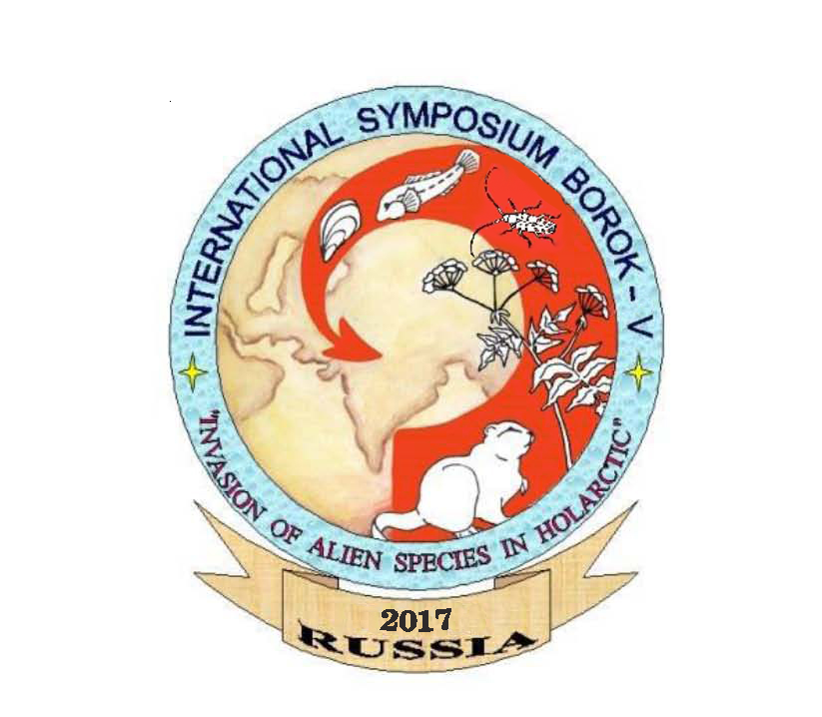
Dear Colleagues!
Preliminary, two optional venues for the V International Symposium "Alien Species in Holarctic. Borok-5" (September 25 – 30, 2017) were supposed: Uglich (Yaroslavskaya oblast) – “The Uglich” sanatorium (http://www.sanatorij.ru/) and “The Moskva” hotel (http://uglich-moskow.ru/). Finally, the selection of the venue will depend on the number of the Symposium REAL (personal) attendants. So, we would be very obliged if you will inform us about your attendance before May 1, 2017. Thank you!
In addition, it is possible to book personally your lodging at any city hotel at your discretion: (https://www.trivago.ru/?iSemThemeId=1794&iPathId=92742&sem_keyword=3068976104&sem_creativeid=730462863&sem_network=search&sem_adposition=2&sem_device=desktop&sem_param1=&sem_param2=&cip=732374041)

The rate of lodging in a standard double room is about 40–50 $ per person/ per day.
It is planned that transfer from Moscow to Uglich and back will be arranged using a special bus service in August (please note the dates!). Preliminary booking is necessary! The transfer fee is approximately 25 $ per one trip. The tickets will be provided.

Please, send the abstracts before May 1, 2017.

The rules for the abstracts’ authors
Language - English. Not more than single page of A4 format. Side spaces both sides, 2 cm. Times New Roman font 12. Single spacing.
1) Title Boldface, centered, not indent from the first line, no line folding; 2) authors’ initials’ and family names, (boldface, centered, , not indent from the first line); 3) affiliation, authors’ post address and е-mail (italics not indent from the first line, centered, no line folding ). 5) Main text first line indent 1 cm; alignment; line folding.

Conference fees:
The participants pay fee of 50 $ at arrival.

Main contact:
WEB-site - http://www.sevin.ru/ASHolarctic/Index.html
Mrs. Lyubov I. Tereschenko
e-mail: borok17@mail.ru
Additional inquiries:
Dr. Alexander V. Krylov – Symposium Vice-Chairman (Borok)
e-mail: krylovamik@gmail.com
Yuriy V. Slyn’ko– Symposium Vice-Chairman (Borok)
e-mail: syv@ibiw.yaroslavl.ru

Third Information letter informing on exact venue will be sent after May 15, 2017.

Cordially! The Conference organizing committee

