DRAFT

Russian Academy of Sciences (RAS)
Division of Biological Sciences (DBS RAS)
Scientific Council of Hydrobiology and Ichthyology RAS
International Union of Biological Sciences (IUBS)
International Society of Zoological Sciences (ISZS)
RAS Commission of Preservation of Biological Diversity
A. N. Severtsov Institute of Ecology and Evolution, RAS (SIEE RAS)
I. D. Papanin Institute of the Biology of Inland Waters, RAS (IBIW RAS)
US Fish and Wildlife Service (US FWLS)
US Geological Survey (USGS)
Hydrobiological Society at RAS (HBO at RAS)
RAS Scientific Council of Research, Preservation and Rational Use of Animal World

Dear Colleagues!
We cordially invite you to participate in the Sixth International Symposium,
"Alien Species in the Holarctic: Borok VI",
To be held September 20-25, 2021 (tentative venue: Uglich, Yaroslavl Province, Russia)
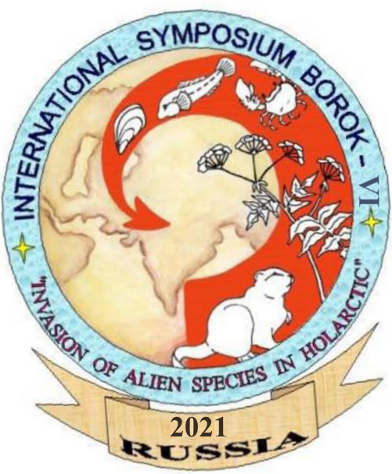

International Symposium, "Alien Species in the Holarctic: Borok VI was first organized 20 years ago and has become regular. During these years, the global problem of biological invasions of alien species has not lost its relevance for humanity.

The main goals of the Sixth Symposium are:
- Consolidation of efforts to study the processes of how alien plant and animal species spread in terrestrial and aquatic ecosystems;
- Exchange of information on the vectors, causes, scales, and directions of species spread; changes in their properties in new aquatic and terrestrial habitats;
- Assessment of the role of the alien species in the transformation of endemic communities; evaluation of social and economic consequences of biological invasions as well as development of risk assessment approaches;
- Discussion of issues related to terminology, theory of species spread and study methods.

Themes of presentations include the following topics:

I. Spatial and temporal dynamics of biological invasions in the Holarctic: 1) invasions in marine ecosystems; 2) invasions in freshwater ecosystems; 3) invasions in terrestrial ecosystems; 4) paleoinvasions.
II. Genetic and evolutionary aspects of biological invasions.
III. Consequences of alien species invasion for aboriginal species and ecosystems and human well being.
IV. Role of global climatic and anthropogenic factors in the processes of biological invasions, including new approaches and methods in research of invasions of alien species.
V. Information systems for monitoring invasion processes, including development of problem-oriented databases and mathematical modelling of the processes related to invasion of alien species.

It is planned that the program of the Symposium will include “Round Tables” with lectures delivered by leading scientists on the following topics:
(1) alien species in urban environment;
(2) social and economic aspects of the processes of biological invasions;
(3) management of biological invasions: risk assessment, prevention and control.

Organizing Committee
Yu.Yu. Dgebuadze – Symposium Chairman, SIEE RAS, Moscow, Russia
A.V. Krylov. – Symposium Vice Chairman, IBIW RAS, Borok, Russia
V.G. Petrosyan – Symposium Vice Chairman, SIEE RAS, Moscow, Russia

Members of Scientific Committee:
Yu.N. Baranchikov - SIF RAS (SB), Krasnoyarsk, Russia
Yu.K Vinogradova – MBG RAS , Moscow, Russia
M.E. Douglas – Univ. Arkansas, Fayetteville, Arkansas, USA
A. Dulmaa – Academician, IB MAS, Ulan Bator, Mongolia
Zhibin Zhang. – ZI CAS, President, International Society of Zoological Sciences (ISZS), Beijing, China
A.Yu. Zvyagintsev – MB RAS (F-EB), Vladivostok, Russia
V.V. Ivin – IMB RAS (F-EB), Vladivostok, Russia
V.T. Komov. – IBIW RAS, Borok, Russia
A.A. Kotov - SIEE RAS, Moscow, Russia
L.G. Korneva . – IBIW RAS, Borok, Russia
E.N. Naumenko – AtlantNIRO, Kaliningrad, Russia
M.I. Orlova – ZIN RAS, St-Petersburg, Russia
I.V. Telesh - – ZIN RAS, St-Petersburg, Russia
L.A. Khlyap. – SIEE RAS, Moscow, Russia
I.Yu. Feneva – SIEE RAS, Moscow, Russia, Secretary of the Scientific Council of Hydrobiology and Ichthyology RAS
Yu.V. Slyn’ko – IBSS RAS, Sevastopol, Russia
T.A. Shiganova - SIO RAS, Moscow, Russia
E.N. Yadrenkina - IASE RAS (SB), Novosibirsk, Russia

Members of Organizing Committee
D.P. Karabanov – Symposium Secretary, IBIW RAS, Borok, Russia
J. Grabowska – Univ. Lodz, Poland
S.G. Kohl – USFWS, Arlington, Virginia, USA
A.A. Makhrov – SIEE RAS, Moscow, Russia
F.A. Osipov – SIEE RAS, Moscow, Russia
D.F. Pavlov – IBIW RAS, Borok, Russia
V.V. Stolbunova – IBIW RAS, Borok, Russia
N. Fomproix – PhD, Executive Director, International Union of Biological Sciences, Paris, France
Chunxu Han – Deputy Secretary General of Chinese National Committee of International Committee of Biological Sciences, Beijing, China

Tentative venue:
Uglich — an ancient city located on the Volga River (the Uglich Reservoir), approximately 200 km northeast of Moscow, 97 km west of Yaroslavl and 90 km from Borok (IBIW RAS). Uglich is deservedly called one of the “Pearls” of the Russian “Golden Ring, which includes the cities and lands considered the historical, cultural and spiritual nuclei of the Russian nation.

Please visit the IBIW RAS web site to register: (…………………….)…

Please register by February, 1, 2021

Organizational Fee (tentative):
Participant | Before May 1, 2021 | After May 1, 2021
Undergraduate/Postgraduate Students | 750 rubles (US $12.50) | 1,000 rubles (US $15.00)
Other (honored) participants | 1,500 rubles (US $25.00) | 2,000 rubles (US $30.00)

Main Working Language — English.

After December 1, 2020 and 2nd Informational Letter will be sent to registered participants. That letter will contain the following information: 1) Symposium venue; 2) Hotel prices; 3) Information on paying the registration fees from the directing organization according to Agreements (if necessary and applicable) and on the personal transfer from the participants; 4) Rules for contributors and dates of Abstract submission.

Contacts (beginning mid - September 2020):

A. V. Krylov - Symposium Vice Chairman (Borok)
e-mail: krylov@ibiw.yaroslavl.ru; tel.: +7(48547)24124
D.P. Karabanov – Symposium Secretary, e-mail: dk@ibiw.ru

